10.3 Editors - Shader Editor - Sidebar
Introduction 1
Right Click menus 1

Introduction

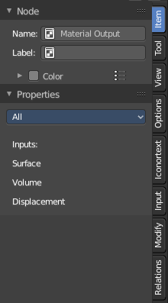
The Shader Editor is made of several areas. At the right side you will find the sidebar. Here you will find further options and settings for the Shader Editor nodes and its tools.

Right Click menus

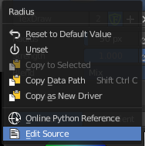
You will open the usual right click menus when clicking with the right mouse at elements in the sidebar. Its content is in big parts self explaining.

The right click menus are explained in the chapter 6 Editors Introduction.

